**Lab 2**

2)Movie rating App

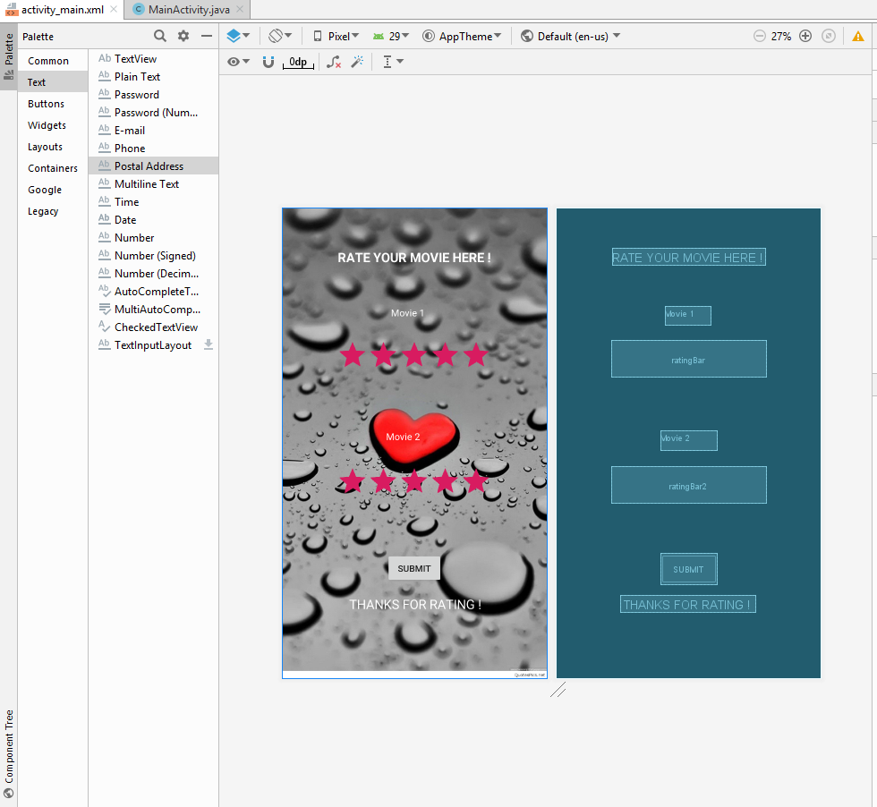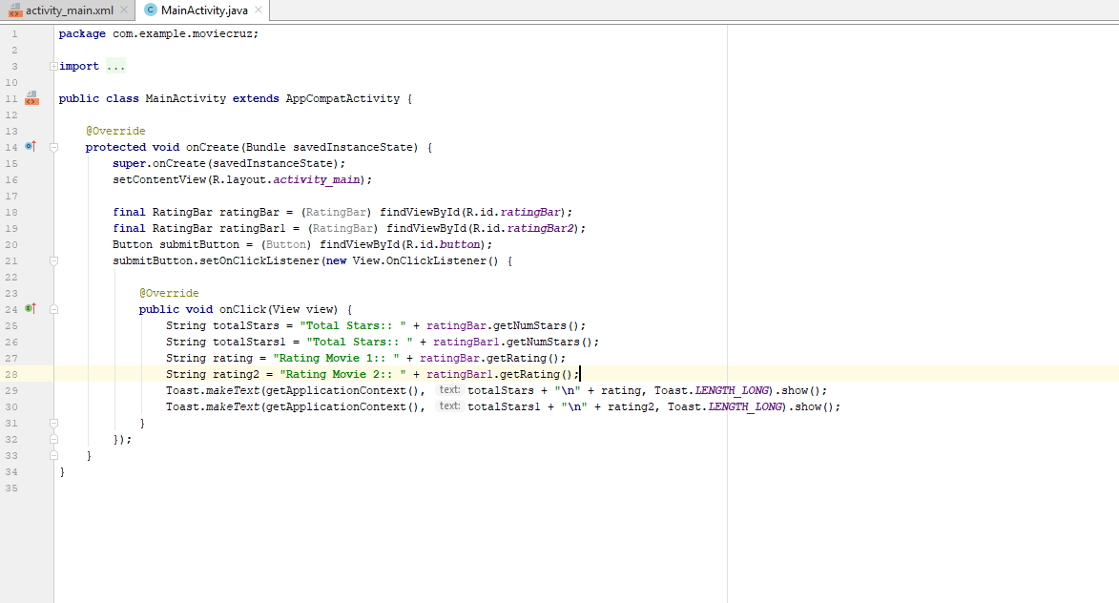

<**androidx.constraintlayout.widget.ConstraintLayout xmlns:android="http://schemas.android.com/apk/res/android"**

**xmlns:app="http://schemas.android.com/apk/res-auto"**

**xmlns:tools="http://schemas.android.com/tools"**

**android:layout_width="match_parent"**

**android:layout_height="match_parent"**

**android:background="@drawable/wall"**

**tools:context=".MainActivity"**>

<**RatingBar**

**android:id="@+id/ratingBar"**

**android:layout_width="wrap_content"**

**android:layout_height="wrap_content"**

**android:rating="@android:integer/config_longAnimTime"**

**app:layout_constraintBottom_toBottomOf="parent"**

**app:layout_constraintEnd_toEndOf="parent"**

**app:layout_constraintHorizontal_bias="0.5"**

**app:layout_constraintStart_toStartOf="parent"**

**app:layout_constraintTop_toTopOf="parent"**

**app:layout_constraintVertical_bias="0.304"** />

<**RatingBar**

**android:id="@+id/ratingBar2"**

**android:layout_width="wrap_content"**

**android:layout_height="wrap_content"**

**android:rating="@android:integer/config_longAnimTime"**

**app:layout_constraintBottom_toBottomOf="parent"**

**app:layout_constraintEnd_toEndOf="parent"**

**app:layout_constraintHorizontal_bias="0.5"**

**app:layout_constraintStart_toStartOf="parent"**

**app:layout_constraintTop_toBottomOf="@+id/ratingBar"**

**app:layout_constraintVertical_bias="0.337"** />

<**TextView**

**android:id="@+id/textView"**

**android:layout_width="71dp"**

**android:layout_height="29dp"**

**android:text="Movie 1"**

**android:textColor="#ffffff"**

**android:textSize="15dp"**

**app:layout_constraintBottom_toTopOf="@+id/ratingBar"**

**app:layout_constraintEnd_toEndOf="parent"**

**app:layout_constraintHorizontal_bias="0.498"**

**app:layout_constraintStart_toStartOf="parent"**

**app:layout_constraintTop_toTopOf="parent"**

**app:layout_constraintVertical_bias="0.87"** />

<**TextView**

**android:id="@+id/textView2"**

**android:layout_width="88dp"**

**android:layout_height="31dp"**

**android:text="Movie 2"**

**android:textColor="#ffffff"**

**android:textSize="15dp"**

**app:layout_constraintBottom_toTopOf="@+id/ratingBar2"**

**app:layout_constraintEnd_toEndOf="parent"**

**app:layout_constraintHorizontal_bias="0.5"**

**app:layout_constraintStart_toStartOf="parent"**

**app:layout_constraintTop_toBottomOf="@+id/ratingBar"**

**app:layout_constraintVertical_bias="0.772"** />

<**TextView**

**android:id="@+id/textView3"**

**android:layout_width="wrap_content"**

**android:layout_height="wrap_content"**

**android:text="RATE YOUR MOVIE HERE !"**

**android:textColor="#ffffff"**

**android:textSize="20dp"**

**android:textStyle="bold"**

**app:layout_constraintBottom_toTopOf="@+id/textView"**

**app:layout_constraintEnd_toEndOf="parent"**

**app:layout_constraintHorizontal_bias="0.5"**

**app:layout_constraintStart_toStartOf="parent"**

**app:layout_constraintTop_toTopOf="parent"** />

<**TextView**

**android:id="@+id/textView4"**

**android:layout_width="wrap_content"**

**android:layout_height="wrap_content"**

**android:text=" THANKS FOR RATING !"**

**android:textColor="#ffffff"**

**android:textSize="20dp"**

**app:layout_constraintBottom_toBottomOf="parent"**

**app:layout_constraintEnd_toEndOf="parent"**

**app:layout_constraintHorizontal_bias="0.497"**

**app:layout_constraintStart_toStartOf="parent"**

**app:layout_constraintTop_toBottomOf="@+id/ratingBar2"**

**app:layout_constraintVertical_bias="0.585"** />

<**Button**

**android:id="@+id/button"**

**android:layout_width="wrap_content"**

**android:layout_height="wrap_content"**

**android:text="SUBMIT"**

**app:layout_constraintBottom_toTopOf="@+id/textView4"**

**app:layout_constraintEnd_toEndOf="parent"**

**app:layout_constraintHorizontal_bias="0.501"**

**app:layout_constraintStart_toStartOf="parent"**

**app:layout_constraintTop_toBottomOf="@+id/ratingBar2"**

**app:layout_constraintVertical_bias="0.813"** />

</**androidx.constraintlayout.widget.ConstraintLayout**>